# COAL LAB 6

Q.1)

Include Irvine32.inc

.data

s byte "Generating 20 random integers between 0 and 990",0

.code

Main PROC

mov edx,offset s

mov eax ,0

mov eax, black + (green*16)

call SetTextColor

call writestring

call crlf

mov eax ,0

mov edx ,0

mov ecx, 20

l1:

mov ebx,ecx

call delay

mov eax, 990

call RandomRange

mov ecx,ebx

add dh,1

add dl,3

call gotoxy

call Writedec

loop l1

exit

Main ENDP

End Main

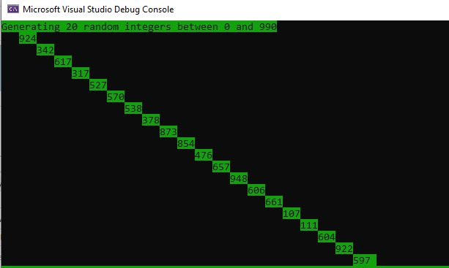

Q.2)

Include irvine32.inc

.data

star byte "*",0

.code

main PROC

mov eax,0

mov edx,0

mov ecx,100

l1:

mov eax,100

call delay

call GetMaxXY

call randomrange

mov dh,ah

mov al,dl

call randomrange

mov dl,al

call gotoxy

mov edx,offset star

call writestring

loop l1

exit

main ENDP

END main

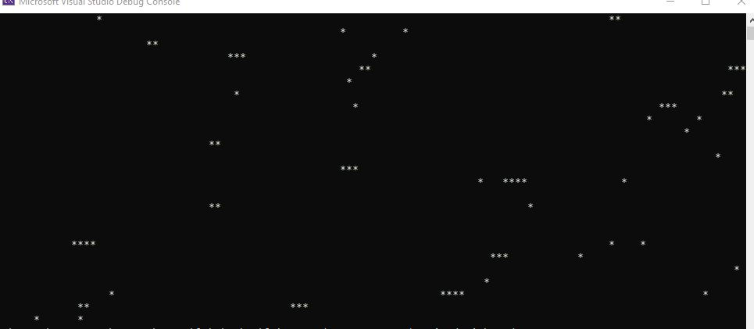

Q.3)

include irvine32.inc

.data

msg1 BYTE "10 unsigned integers ",0

msg2 BYTE "10 signed integers ",0

.code

main proc

call randomize

mov ecx,10

mov edx,offset msg1

call writestring

call crlf

l1:

mov eax,+4294967294

call randomrange

call writedec

call crlf

loop l1

call randomize

call crlf

mov edx,offset msg2

call writestring

call crlf

mov ecx,10

l2:

mov eax,99

call randomrange

sub eax,50

call writeint

call crlf

loop l2

exit

main endp

end main

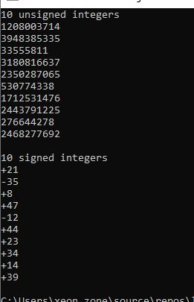

Q.4)

INCLUDE Irvine32.inc

BUFFER_SIZE = 501

.data

buffer BYTE BUFFER_SIZE DUP(?)

filename BYTE "MyFile.",0

fileHandle HANDLE ?

stringLength DWORD ?

msg1 BYTE "Enter text you want to write to the file: "

.code

main PROC

mov edx,OFFSET filename

call CreateOutputFile

mov fileHandle, eax

mov edx,OFFSET msg1

call WriteString

call crlf

mov ecx,BUFFER_SIZE

mov edx,OFFSET buffer

call ReadString

mov stringLength,eax

mov eax,fileHandle

mov edx,OFFSET buffer

mov ecx,stringLength

call WriteToFile

call CloseFile

exit

main ENDP

END main

